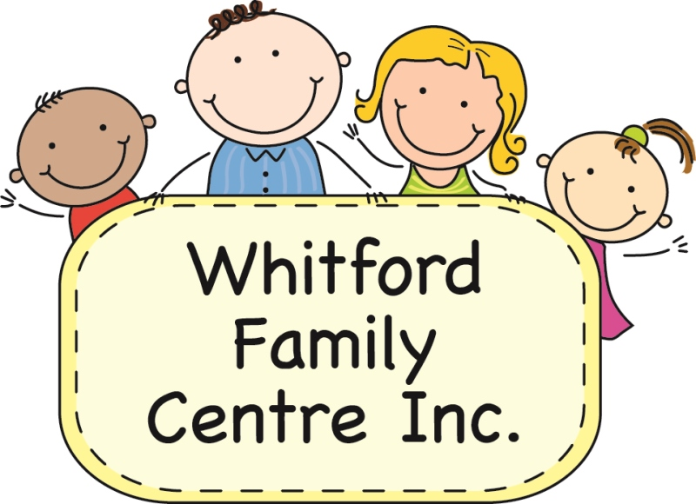

ENROLMENT NIGHT for 2018
(Annual General Meeting)

MONDAY 13th November 2017 – 7pm

ALL WELCOME

- Meet the staff
- Sign up for Pre-Kindy 2018
- Hear about what the centre does
- Vote in 2018 Committee

Consider being on the WFC Committee – this is what they do -
Attend meetings when you can. (held once a month)
Help make decisions for the centre and kindy program.
Do what you can to help, such as - minutes of the meeting, Facebook posts, order fundraising chocolates, organise garden clean up, suggest new ideas.
Meet new friends and escape the house!
Tracey and Carolyn are in the Office to support you and help get things done.



